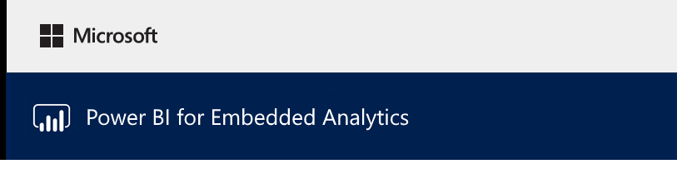

### Lab 01

# Overview

The estimated time to complete the lab is 10 minutes

In order to complete this lab, you will require a connection to the Internet and an HTML 5 standards compatible web browser. There is no requirement to sign in to Power BI.

In this lab, you will be introduced to the JavaScript API for Microsoft Power BI, and explore how to enable in-context analytics within an application using the API.

You will use a demo application pre-built to enable you to quickly use each method provided by the JavaScript API, and you’ll see the coding patterns required. The interactive experience will help you understand the code behind in-context analytics.

A report will be made available to you within the application. The sample application will use the provided report to enable you to explore several JavaScript API capabilities.

You will learn how to:

* Use a sample application to explore JavaScript API capabilities

### Embedding the Report

In this task, you will embed the report into a sample application.

1. In Internet Explorer, create a second web session.
2. Navigate to <https://microsoft.github.io/PowerBI-JavaScript/demo/code-demo/>.

Tip: You can use the Power BI Report Embed Sample browser favorite.

This app was designed to enable experimenting with Power BI Embedded without developing an application. It works with either a pre-published report, or with your reports imported into a Power BI Embedded workspace. In this lab, you will embed the report from your workspace collection.

1. Along to page banner, notice the workflow that the sample application supports.

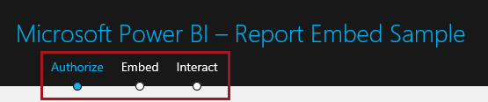

This page, then, commences with the Authorize stage. It is possible to switch between the stages, once authorization has been completed.

1. In the lower part of the page, in the Sample Report tab, press “Embed sample report”.

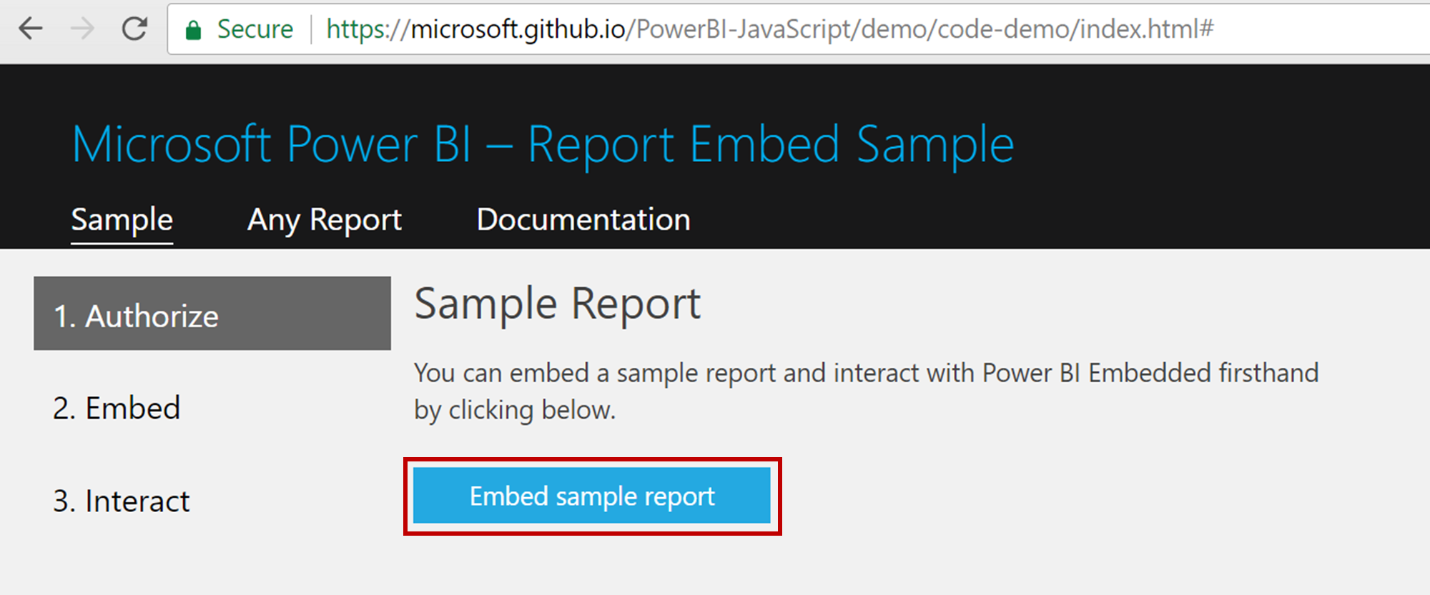

1. In the new page, notice the **code** box and the **log viewer** box. As you operate this lab actions you take on the code box will result in messages in the log viewer box.
2. In the Code box, review the JavaScript code designed to use these values to embed the report into the lower pane.
3. To run the code to embed the report, in the Code box, at the top-right corner, click Run.

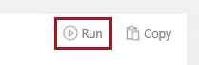

1. In the lower pane, ensure that your report loads.

This will be supported by feedback loaded in the log viewer.

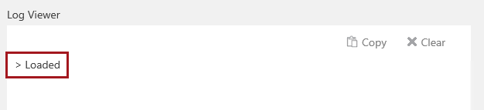

If the report does not load, you can either return to the previous exercise and try again, or return to the first page of the sample application, and then click Embed Sample Report.

1. Interact with the report by changing slicer values, by highlighting visual elements, and by selecting different pages.
2. To clear the log comments, in the Log Viewer box, at the top-tight corner, click Clear.

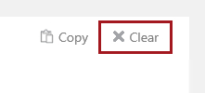

### Exploring the JavaScript API Capabilities

In this task, you will explore several capabilities supported by the JavaScript API.

1. Navigate to the Interact page.

It is important to understand that all of the programmatic operations you work with in this task are achieved by client-side script.

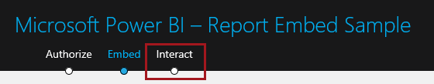

1. At the top-left corner, notice the dropdown list, and that it is currently set to Report Operations.

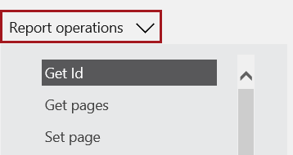

1. Notice also that the Get Id operation is selected.

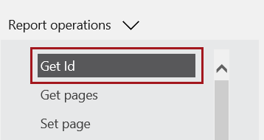

1. In the Code box, review the JavaScript code designed to perform the selected operation.
2. To run the code, in the Code box, at the top-right corner, click Run.



1. In the Log Viewer box, review the output, and then click Clear.



1. Work through the following list of operations, being sure to clear the log viewer between each.

|  |  |
| --- | --- |
| Operation | Directions |
| Get pages |  |
| Get filters | You can open the Filters pane, and check several product items |
| Remove filters | In the Filters pane, notice that the Product filter has been removed |
| Print | Notice that the browser print workflow is triggered |
| Update settings | Notice that the Filters pane is removed |
| Reload | Notice that the report is reloaded, and that the report-level filters have reappeared |
| Full screen | In full screen mode, expand the Filters pane. Click Escape to exit this mode. |

1. Select Page Operations.

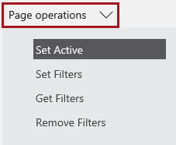

1. Work through the following list of operations, being sure to clear the log viewer between each.

|  |  |
| --- | --- |
| Operation | Directions |
| Set active | Notice that the second page has been selected |
| Get filters | No page-level filters have been defined in the report. |

1. Select Event Listener.

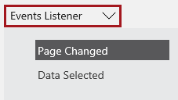

1. Work through the following list of operations.

|  |  |
| --- | --- |
| Operation | Directions |
| Page changed | Once running, navigate to different pages |
| Data selected | Once running, change slicer selections, and highlight visual elements (columns and bars) |

You have now completed exploring the embedded report with various JavaScript API capabilities.